**Assignment -6**

**Title:** To study and implement various membership functions in MATLAB.

**Theory:**

* **Fuzzy Set:** Fuzzy set, as the name implies is a set without a crisp boundary. That is, the transition from “belong to a set”, to “not belong to a set” is gradual, and this smooth transition is characterized by membership functions that give fuzzy commonly used linguistic expressions, such as “the water is hot” or “the temperature is high”. Such imprecisely defined sets or classes play an important role, in the domain of pattern recognition.

If **X** is a collection of objects denoted generally by **x,** then a fuzzy set **A** in **X** is defined as a set of ordered pairs:

**A={ (x,µa(x) | xεX };**

where **µa(x)** is a membership function for the fuzzy set **A.**

* **Membership Function:** Membership Function defines the fuzziness in a fuzzy set irrespective of the elements in the set, which are discrete or continuous. The Membership Function defines all the information contained in a fuzzy set.

The Membership Function maps each element of **X** to a membership grade (or value) between 0 or 1.

Here **X** is referred to as the universe of discourse (information).

**Types of Membership Function (1-Dimensional):**

1. Triangular Membership Function
2. Trapezoidal Membership Function
3. Gaussian Membership Function
4. Generalized Bell Membership Function
5. Sigmoidal Membership Function

**Triangular Membership Function-**

Triangular Membership Function is specified by 3 parameters {a,b,c} as follows:

triangle(**x**;a,b,c)= 0 ; x<=a

= (x-a)/(b-a); a<=x<=b

= (c-x)/(c-b); b<=x<=c

= 0; c<=x

An alternative expression for triangular membership function:

triangle(**x**;a,b,c)=max(min(((x-a)/(b-a)),(c-x)/(c-b)),0)

The parameters {a,b,c} (with a<b<c) determine the **x** coordinates of the three corners of the underlying triangular MF (**x;**20,60,80).

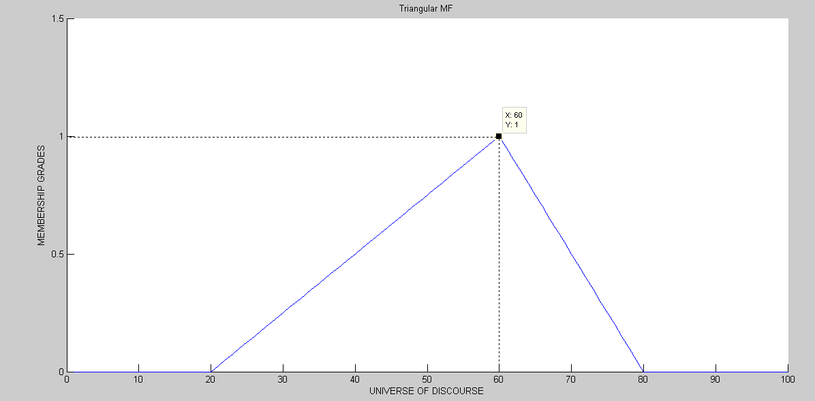

**Trapezoidal Membership Function-**

A trapezoidal MF is specified by 5 parameters {a,b,c,d} as follows:

trapezoid(**x;**a,b,c,d)=0 ; x<=a

=(x-a)/(b-a) ; a<=x<=b

= 1 ; b<=x<=c

=(d-x)/(d-c) ; c<=x<=d

= 0 ; d<=x

An alternative expression for trapezoidal membership function:

Trapezoidal(**x**;a,b,c,d)=max(min(min(((x-a)/(b-a)),1),((d-x)/(d-c))),0);

The parameters {a,b,c,d} (with a<b<c<d) determine the **x** coordinates of the four corners of the underlying trapezoidal MF(**x;**10,20,60,95).

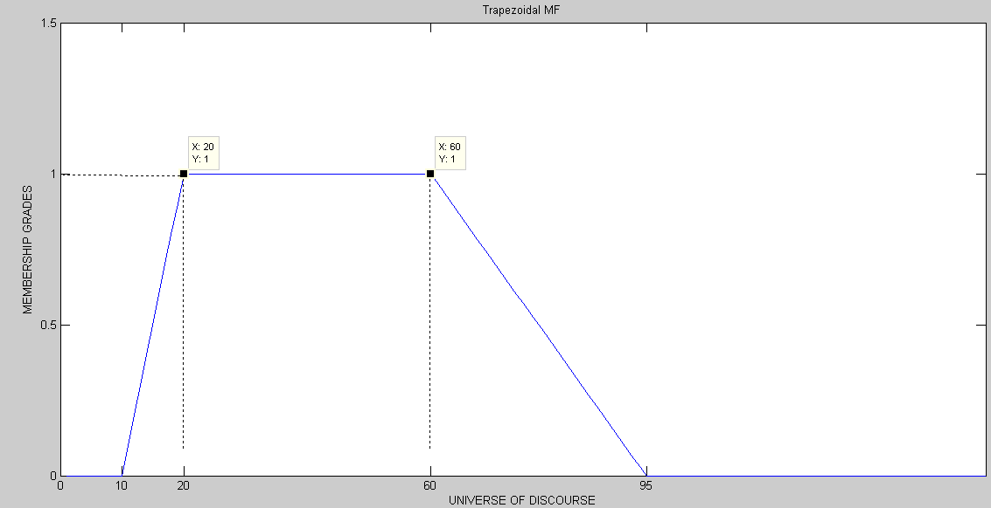

**Gaussian Membership Function-**

A Gaussian MF is specified by two parameters {C,σ}.

Gaussian(**x**;C,σ)= e[(-1/2)*((x-C)/ σ) ^2].

A Gaussian MF is determined completely by C and σ, C represents the MF’s centre and σ determines the MF’s width.

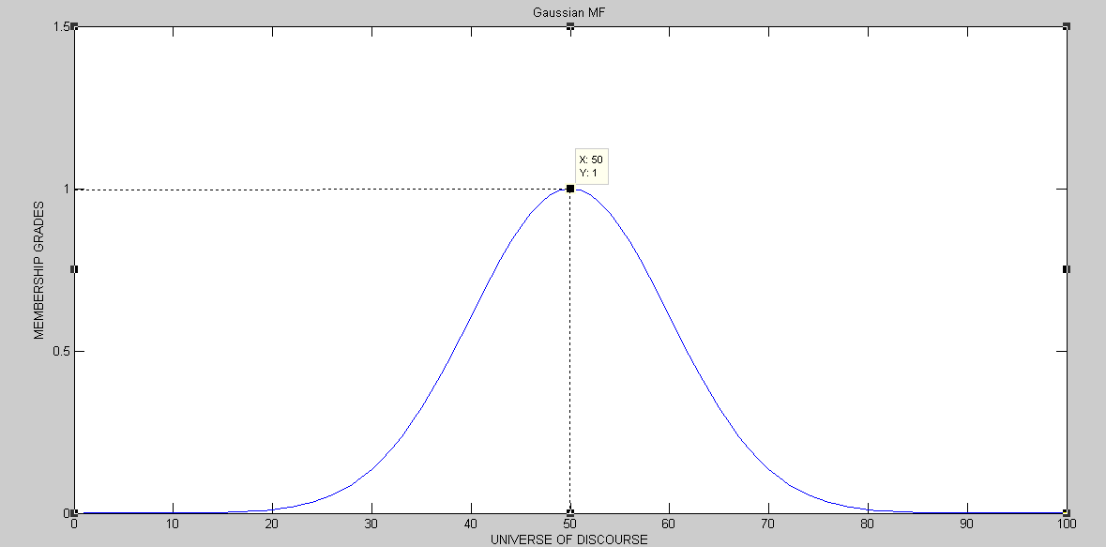

**Generalized Bell Membership Function-**

A generalized bell MF (or bell MF) is specified by three parameters {a,b,c}.

bell(**x**;a,b,c)=1/(1+|(x-c)/a|2*b).

where the parameter b is usually positive (if b is –ve, the shape of this MF becomes an upside down bell).

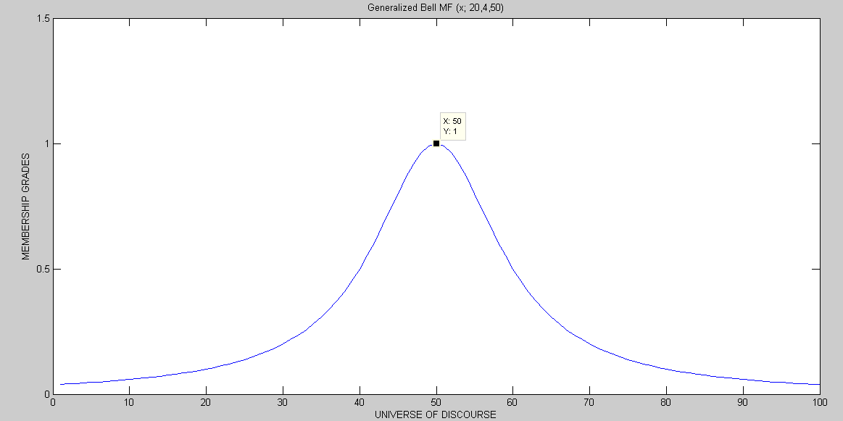

Figure 1: bell(x;20,4,50)

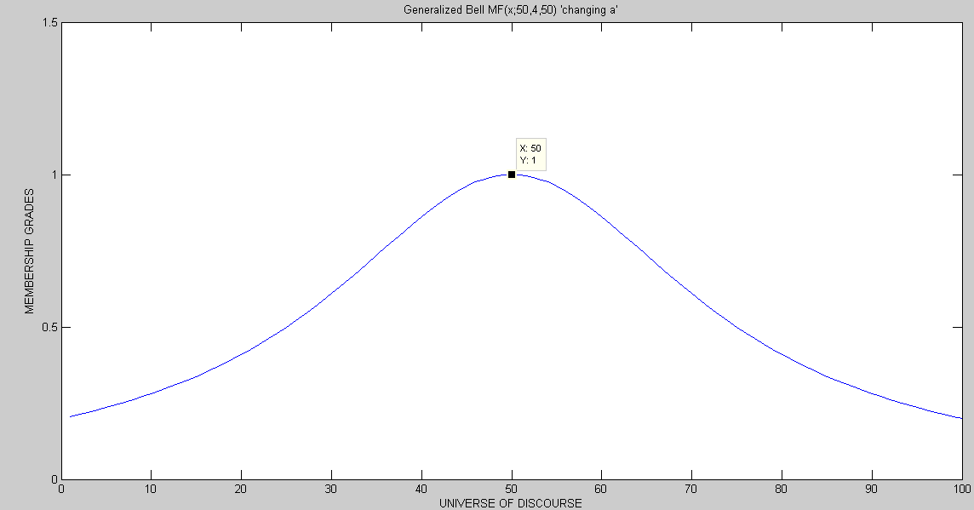

Figure 2: bell(x;50,4,50) ‘changing a’

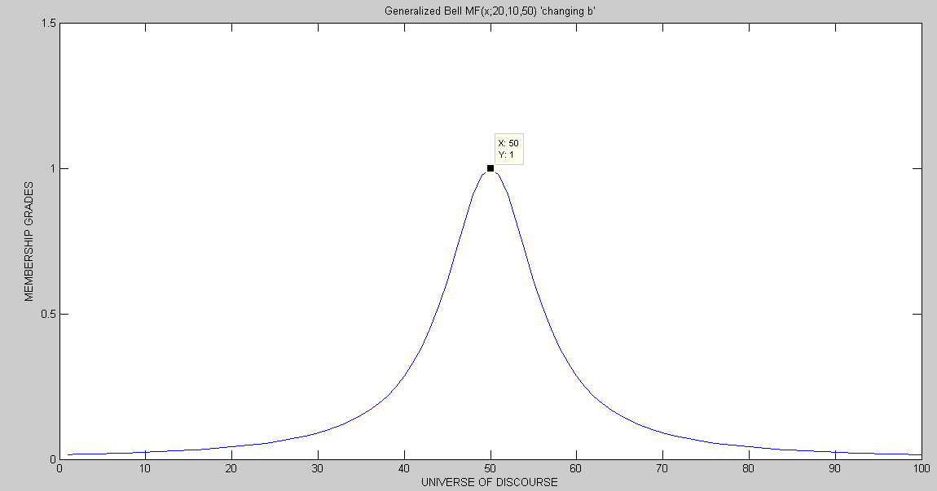

Figure 3: bell(x;20,10,50) ‘changing b’

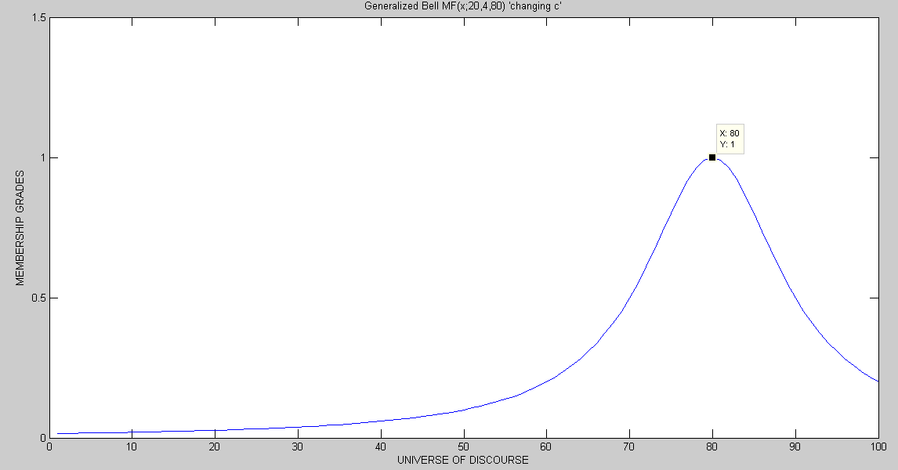

Figure 4:bell(x;20,4,80) ‘changing c’

**Sigmoidal Membership Function-**

Sig(**x**;a,c)=1/(1+e(-a*(x-c)).

where **a** controls the slope at the crossover point **x=c.**

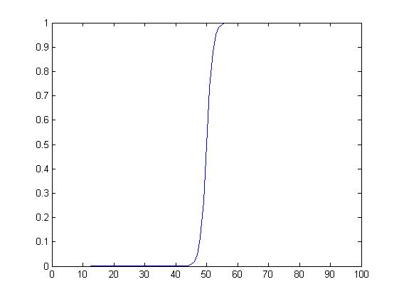

**FAQs:**

**1.** What are the alternative expression (using MIN and MAX) of trapezoidal membership function and show how to obtain triangular membership function from that expression.

**2.** What does ‘C’ and ‘σ’ represent in Gaussian MF expression?

**3.** Show the effect of changing a, b and c in Generalized bell MF expression, with a suitable example.

**4.** Write the expression of Sigmoidal MF and significance of all the parameters used in the expression.